Staff DCS PD - 23rd Jan 2026
- Andrew Manning
  - Principal
- Mission
- School vs Church
  - DCS providing authentic, high quality education bible based, transformational
- Challenge, to respect and understand what was, looking at what is, and what will be
- Berakah
  - Strategic Theme
    - Consolidated Growth
  - Authentic in delivery of distinctive Christian Education
  - The board will come up with a new strategic plan soon
- 6 Strategic Priorities
  - Christ Centred Foundations
  - Educational Strength
  - Student Wellbeing
  - Partnership and Community
  - Operational Sustainability
  - Governance and Accountability
- 2026 Annual Plan for DCS

School Priorities 2026
- Foster Christian Distinctiveness
- Implementation the DCS Learner Profile
- Develop the 2027-2030 Strategic Plan
- 2026 Organisational Transition
- Establish the DCS Welfare Framework

- 880 by 2032
  - Transitions (Paul and Andrew)

- Annexe A – Tactical Framework

- 2026 Dubbo Christian School Annual Plan
- Not using Gym today, big fans are changing height
  - Being raised

- BCE BM Operational Update – Part 1
Scotty Morris (Business Manager)
Beryl Cosier (HR Manager)

- Plan for next 5 Years
  - 880 in 2032

- Scope
  - BCE Update
  - Enrolment Update
  - Infrastructure
  - HR
- Enrolment
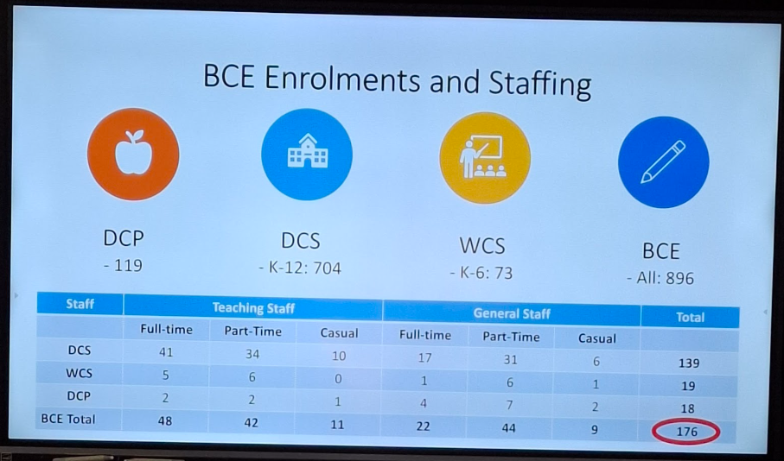
- Secondary –7 between 2025 and 2026

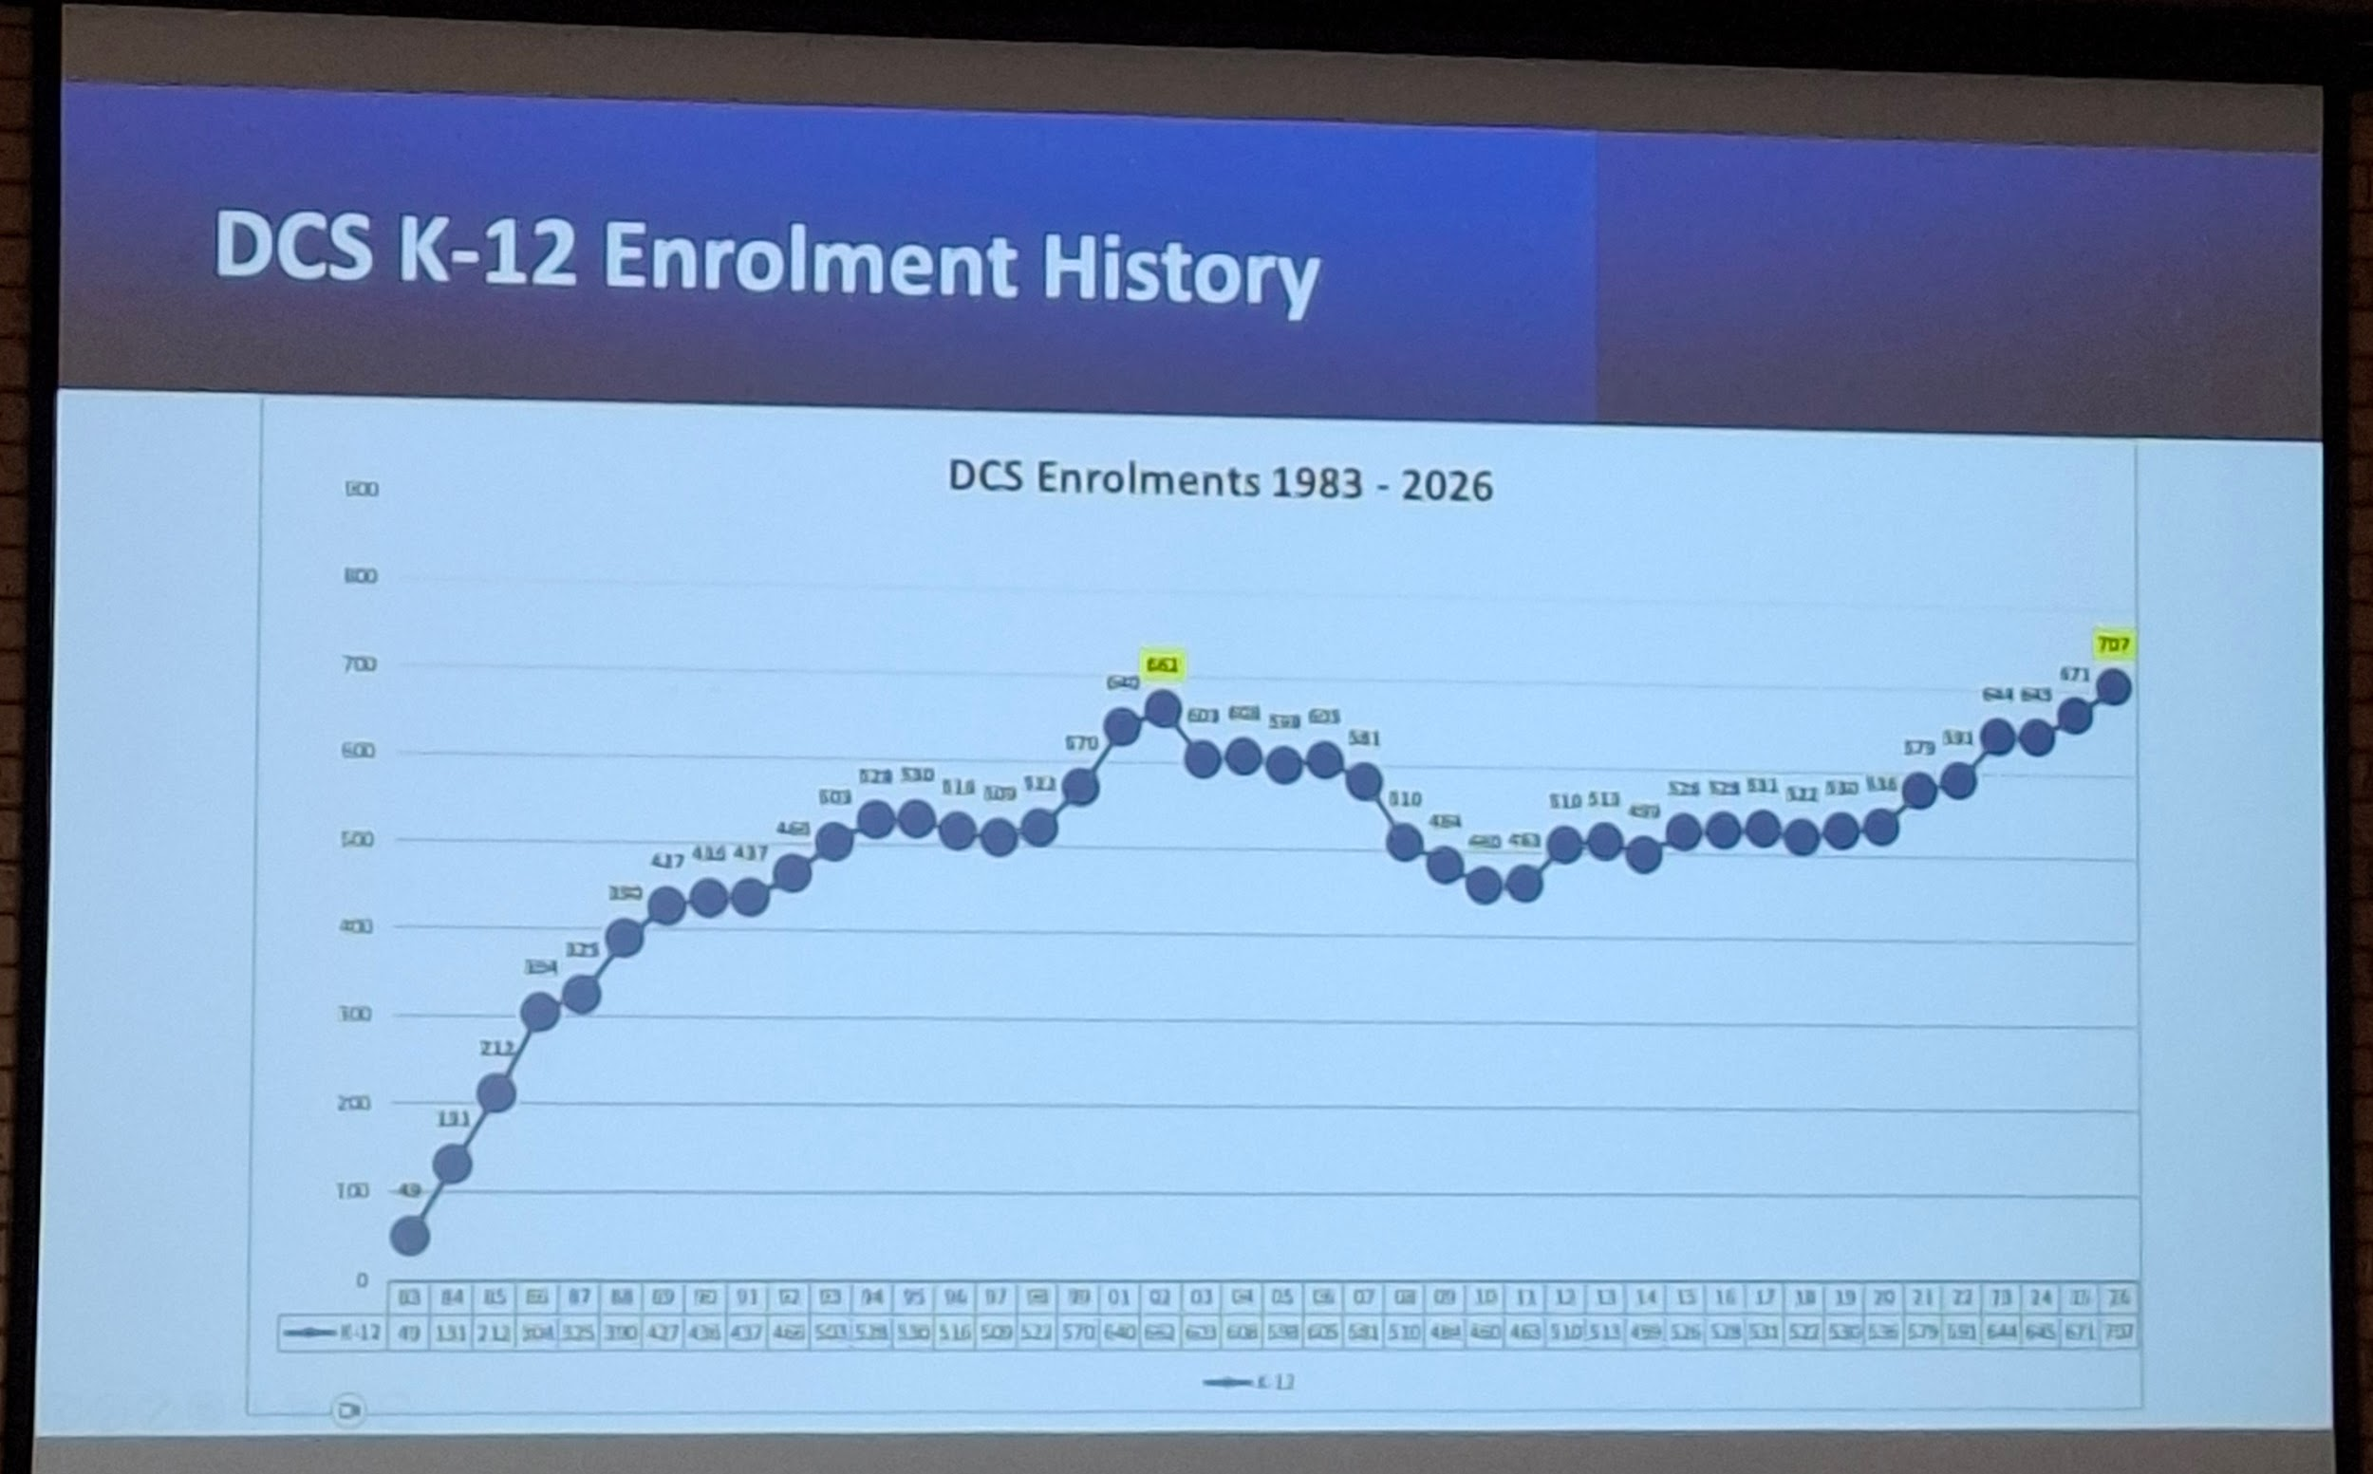

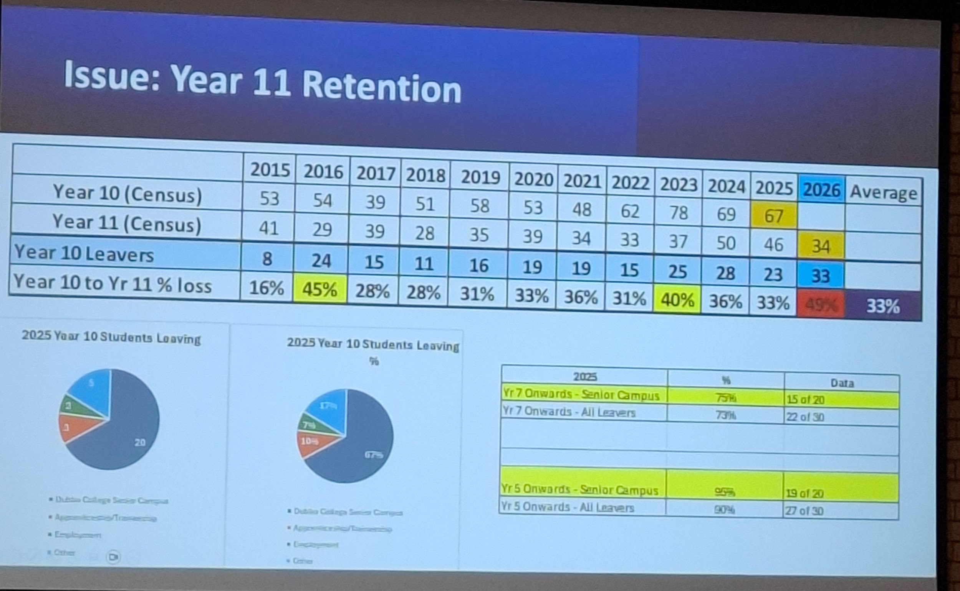

- Infrastructure
  - 9.5 million in loan balance
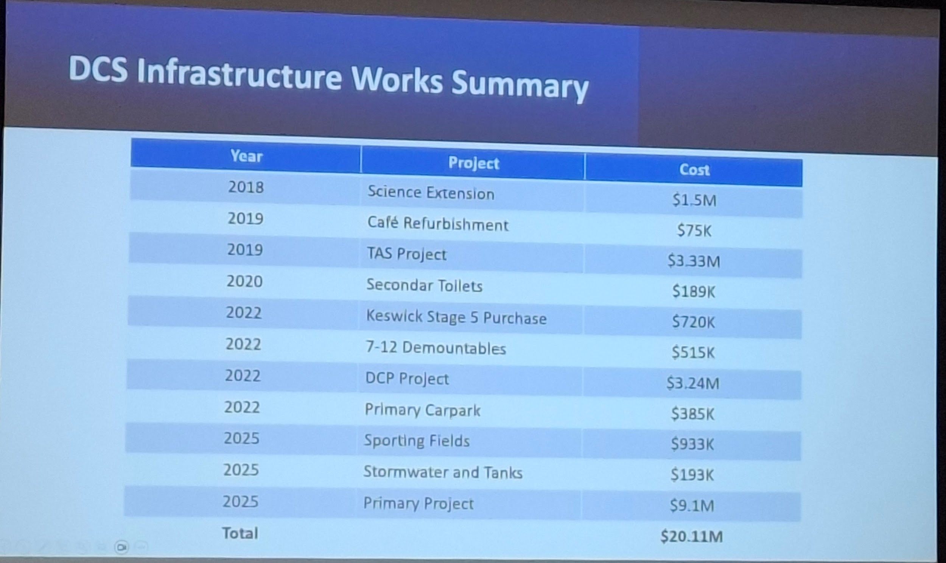

- 2 million worth of grants, 1 million a year into loans
- The Lord has blessed us

- 2026 Infrastructure
  - Gym Fans - $80,000 Project
    - Each fan is $19,000, 50 percent damage if kicking soccer balls ($9500)
- Primary Project
  - Room Relocations
  - ‘No man's land’ Lawn
- Senior Study Relocation
  - Primary Maths resources to Block 15
  - English Texts to Block 4
  - Textbooks and Teacher ref to Rm 8
  - Relocation of Non-Fiction
- Lots of library changes have happened

- Block 4 Refurbishment
  - Not 1,2,3,4
  - 41,42,43,44
  - Carpet
  - Bifold Door Installation

- Classroom changes
  - Faculty Zones
  - Renumbering
  - Furniture retribution
  - Room 37

- Choose 9 that will bring in Briefing - 9 for BINGO
  - Keys
  - Punctuality
  - Compass
  - Team
  - Cafe Reminders
  - Facebook
  - Hot weather
  - Hats
  - Bell times
- Goldies Voucher
  - Ran by ex DCS Students
- Mentioned or Talk about at Length
- TEAM
  - Trust
  - Encouragement
  - Accountability
  - Mateship
- Big rocks in jar first
- Friday Shoutouts

- What's a compass group?
  - PCG
- If away, enter leave into Xero as soon as reasonable
- Staff email signatures
  - Ruth sending instructions

Scott Morris Briefing - Infrastructure
- Glass this morning in Senior Study
  - Downstairs library
- Old Senior Study
  - Upstairs left
    - Trusted Study Pass, study upstairs.
  - Upstairs Right
    - Holding Spare.
    - Space for the first time in a very long time.
    - Possibly small elective class going forward
      - 4-5 students
- Easter
  - Room 17 and Room 18 Refurbishment
  - Library Recarpet
- July
  - Food Tech Refurbishment
- TBC
  - HSIE Staff Room Relocation
  - DCS Bore
  - Primary Playground

HR Update - Beryl
- Beryl
  - HR Update
  - Answers to FAQ’s
- Jury Duty
- Leave is checked as part of Payroll Process
- Medical Certificates and Sick Leave (2nd Day - Email Payroll)
  - Many ways to provide evidence, Doctor Medical Certificate
  - Chemist - Med Certificate
  - Stat Dec - JP (Pedr is a JP)
  - My Gov have a stat dec that doesn’t require a JP
- Casual Employment
  - Casual Sheets Tues 11am (Recess)
- MEA
- Staff Wellbeing
  - EAP
  - Harassment/Bullying Policy
  - WHS - Safety Incidents
  - Defibrillators
- Right to Disconnect Policy

- Audits look at absent staff vs entries
- HOD - Head of Department
- Beryl and Pedr share the payroll role
  - payroll@dubbocs.edu.au
  - Don’t email people directly
- Next week is the biggest payday of the year (Fridays)
  - In 4 days (next week)
- If Stand down
  - Salary averaging
- Long Service Leave
  - Application on DCS HR Tile
  - Very complicated, system hard to keep track
  - Pedr keeps track
- MEA
  - General and Teaching Staff MEA now approved
- Fitness Passport
  - Dubbo Christian School is part of this
  - Asks for a number, put a random number
- Staff Wellbeing
- Harassment and Bullying Policy
  - No tolerance
- WHS - Safety Incidents
  - If an injury occurs while working here, complete safety incident form. On OurDCS
  - Even if minor, needs to be reported.
  - Some minor injuries become major injuries.
  - Have to be declared fit for work
  - What if an existing injury external becomes exacerbated?
  - There is a WHS committee
- Defibrillators
  - 4 located in DCS
    - Gym
    - Office
    - Primary
    - Hall
  - 1 in Preschool
  - Located in Cabinet with Alarm
  - Shut door, alarm turns off
  - Rosanne checked working order every day
  - Clipboard and Pen on top of every cabinet

- Right to Disconnect Policy
  - Located on Policy Connect, accessed through OurDCS
  - Now listed in new MEA for teaching and general staff
- Outside employees working hours, may refuse to respond to after hours work contact with colleagues
  - Right to disconnect does not prohibit employee making contact with you
- Relates to 3rd parties as well
  - Parents
- If a doctor's letter says unfit based on the letter, can I return earlier?
  - No, cannot return before that date

how does this apply to my ICT and Library role at Dubbo Christian school
Clarifying Dubbo's Application
I'm now focusing specifically on how the NSWCS FWC Approval General Staff 2024 document interacts with the user's Dubbo Christian School role. I need to pinpoint the relevant clauses. This involves identifying any potential ambiguities or contradictions and their practical implications, to determine how they impact the user's situation.
Analyzing Contractual Details
I'm now diving into the user's uploaded documents – the Letter of Offer, Standard Terms, and Position Descriptions for their Library Assistant and IT Support Assistant roles. My primary goal is to extract key details like employment level, working hours, and the specifics of their dual-role arrangement. This data will be cross-referenced with the previously analyzed agreement to identify any relevant clauses that might clarify or impact their situation. I need to be sure I am working with the most up-to-date analysis of that agreement, so I am re-fetching it for comparison.
Refining Data Extraction
I've got the contracts and Position Descriptions now, and I'm focused on extracting critical information. I'm prioritizing the employment classification level and working hours from the Letter of Offer. I'm also looking for any specific details on the dual-role arrangement. I am cross-referencing this against the latest version of the FWC Approval document, ready to quote specific clauses if needed.
Considering Role Applicability
I'm presently focused on how the uploaded files relate to my ICT and Library responsibilities at Dubbo Christian School. I've begun reviewing the Enterprise Agreement (NSWCS FWC Approval General Staff 2024.pdf) to identify relevant clauses. My initial assessment centers on identifying sections that pertain to my employment, particularly those related to job descriptions, performance expectations, and professional development. I'm taking notes on potential areas of applicability.
Concluding Role Applicability
I have finished the initial review of the provided documents. I can see the "Letter of Offer/Appointment" clarifies job title details, while the "DCS Contract Enclosure Pack" outlines standard terms. The "Position Description-DCS Library Assistant" and "IT Support Assistant" documents are particularly relevant, though dated, offering specific role requirements. I'm now ready to address the question of applicability.
Refining Applicable Terms
I've shifted my focus to the newly provided documents. I'm now comparing my understanding of the Enterprise Agreement to the specifics in the "DCS Contract Enclosure Pack," and the two "Position Description" files. I'm looking for direct correlations between the EA's general guidelines and the practical application to my roles. I'm noting specific clauses that relate to job functions and pay scales, with a focus on any discrepancies or clarifications they provide.
Analyzing Role Alignment
I'm now integrating the fetched file content to solidify my role analysis. I've noted my dual role as IT Assistant and Library Technician, per my Letter of Offer. I'm focusing on the classification definitions in the Enterprise Agreement and comparing them against the "Level" designations in both Position Descriptions. I'm noting potential overlaps or inconsistencies.
Evaluating Role Classifications
I'm now diving into the implications of my dual role. The IT Support Assistant PD designates "School Administrative Service - Level 3," while the Library Assistant PD, surprisingly, has "Level 2" (Wait, snippet says "School Administrative Service - Level 2" or "School Support Services"? Snippet says "School Administrative Service - Level 2" in the PD header). The Enterprise Agreement (Clause 19) becomes key due to my mixed functions. I need to figure out how salary is handled, considering the different levels and if I am working higher duties. The offer letter snippet is unhelpful for actual salary.
Clarifying Employment Terms
I'm now zeroing in on the specifics of my employment based on all gathered data. I have confirmed I'm classified as Information Technology Assistant and Library Technician, and noted the importance of the Faith Basis within the contract, as well as Permanent Part-time hours. I'm focusing on the implications of a Level 2 Library Assistant and a Level 3 IT Support Assistant, especially the salary structure. I need to synthesize the answer to explain the contract.
Determining Dual Role Impact
I'm now determining how my dual role as IT Assistant (Level 3) and Library Technician (Level 2) affects my compensation and entitlements, per my offer letter and role specifics. I'm focusing on the Enterprise Agreement's mixed functions clause (Clause 19), and its application to a permanent part-time position where mixed duties are performed. I need to understand whether this is a Level 3 classification due to significant combined duties, a composite rate, or split rates. I'll need to check my payslip to clarify.
I'm checking if the Enterprise Agreement defines a threshold of significant to the duties, and if that impacts my classification.
Based on the specific documents you have now uploaded—including your Letter of Offer addressed to Joshua Parris, your Position Descriptions (PDs), and the Enterprise Agreement—here is a detailed breakdown of how these apply to your employment at Dubbo Christian School.

1. Your Role & Classification Levels
Your Letter of Offer explicitly appoints you to a dual position: "Information Technology Assistant and Library Technician".
Crucially, the two Position Descriptions you uploaded assign different classification levels to these two halves of your job:
- IT Support Assistant: Classified as Level 3 (School Administrative Service).
  - Key Duties: 1st and 2nd level support, troubleshooting, creating users, and training staff.
- Library Assistant: Classified as Level 2 (School Administrative Service).
  - Key Duties: Circulation desk, shelving, repairing books, and helping students locate resources.

2. The "Mixed Functions" Pay Implication
Because your job combines a Level 2 role and a Level 3 role, the Mixed Functions clause (Clause 19) of the Enterprise Agreement is critical.
- The Rule: The agreement generally states that if you are engaged to perform duties of a higher classification (Level 3) for more than 5 days, you should be paid at the higher rate for the whole period.
- Application to You: Since you are permanently employed in this dual capacity, you should verify how your salary is being calculated.
  - Best Case: You are paid at Level 3 for all your hours, acknowledging that the IT complexity "lifts" the value of your overall role.
  - Split Rate: The school might pay you Level 2 rates for Library hours and Level 3 for IT hours.
  - Action Item: Check your payslip. If you are being paid entirely at Level 2, you may be underclassified, given that you have a formal PD assigning you Level 3 responsibilities.

3. Salary Rates (General Staff Agreement 2024)
Based on the Enterprise Agreement and your Start Date (Nov 2025), you fall under the rates effective from Feb 2025.
- Level 2 (Library base): Approx. $67,168 (Step 1) to $73,086 (Step 5) per annum (pro-rata for part-time).
- Level 3 (IT base): Approx. $73,157 (Step 1) per annum (pro-rata).
- Note: These figures are estimates based on the "School Operational Services" table in the snippet; your PD says "Administrative Service", which usually has a very similar or identical pay scale, but it's worth cross-referencing the specific "Administrative" table in the full schedule if available.

4. Essential "Faith Basis" Requirements
Your contract places a heavy legal weight on your personal faith, more so than a standard commercial contract. By signing the "Standard Terms and Conditions of Ministry," you have legally agreed to:
- Church Attendance: "Regularly and frequently attend a Christian church".
- Lifestyle: Maintain a lifestyle consistent with the School's Statement of Faith.
- Consequences: The contract states that ceasing to meet these faith requirements is grounds for summary termination (immediate firing).

5. Probation & Part-Time Status
- Probation: Standard contracts usually include a probation period (often 6 months). Ensure you are aware of when this period ends.
- Part-Time Entitlements: As a "Permanent Part-time" staff member, you get pro-rata annual leave and sick leave. You are also entitled to be paid for Public Holidays that fall on your rostered work days, but not those that fall on your non-work days.

Summary Checklist for Joshua
- Check Payslip: Confirm if your hourly rate matches Level 3 ($73k+ full-time equivalent) or Level 2 ($67k+ full-time equivalent).
- Clarify "Mixed Functions": If you are paid Level 2, ask HR how the "Level 3" IT duties in your PD are accounted for under Clause 19 of the Agreement.
- Holidays: Confirm if you are "Term Time Only" (unpaid during school holidays) or if you work through holidays (common for IT staff but less common for Library staff).
I am doing IT 3/10 days out of a fortnight, 6/10 days out of fortnight library, 1/10 days of the fortnight I have off / leave as I work 0.9
Refining Pay Classification
Now, I'm integrating the user's detailed work schedule – 3 IT days, 6 Library days, and a day off every two weeks. This fresh data is crucial. It drastically improves my ability to pinpoint the most accurate job classification and potential pay discrepancies, especially in relation to the "Mixed Functions" clause. The new schedule makes things much clearer now.
Verifying Mixed Functions Threshold
I'm now diving deep into Clause 19 of the General Staff Agreement. My primary focus is pinpointing the precise threshold for "Mixed Functions." It's imperative that I verify the "5 days" trigger. Is it referring to 5 consecutive workdays, an accumulation over a period, or something else entirely? The "NSWCS FWC Approval General Staff 2024.pdf" file will be my primary resource to make a determination.
This split of duties is significant. Under the Mixed Functions (Clause 19) of the NSW Christian Schools General Staff Agreement, the specific breakdown of your days (3 IT, 6 Library, 1 Off) has a direct impact on your pay entitlement.
Here is how your specific roster applies to the rules:

1. The "Higher Duties" Rule (Clause 19)
The agreement typically states that if you work at a higher classification (Level 3 IT) for more than 5 consecutive days, you get paid the higher rate for the whole period.
- Your Situation: You are doing IT for 3 days a fortnight. This is likely less than 5 consecutive days at a time.
- The Result: The school is likely entitled to pay you "pro-rata" based on the duties performed.
  - 3 Days (IT): Paid at Level 3 rate.
  - 6 Days (Library): Paid at Level 2 rate.
  - 1 Day (Leave): Paid at your "normal" rate (likely a blend or your primary classification).

2. The Financial Difference
Since you are 0.9 FTE (Working 9 days out of 10), your pay should ideally be calculated as a composite hourly rate or two separate cost centers.
- Level 3 (IT) Hourly Rate: Approx. $37.00 - $38.00 / hr (estimate based on $73k annual).
- Level 2 (Library) Hourly Rate: Approx. $34.00 - $35.00 / hr (estimate based on $67k annual).
- Note: These are estimates. Check your payslip for the exact "Base Hourly Rate".
Critical Check: Look at your payslip. Does it show two separate lines for ordinary hours (e.g., "Ord Hrs Lvl 3" and "Ord Hrs Lvl 2")?
- If YES: They are paying you correctly for the split role.
- If NO: They are likely paying you entirely at one level.
  - If it's all Level 2, you are being underpaid for those 3 days of IT work every fortnight.
  - If it's all Level 3, you are better off (the school has simplified it in your favor).

3. Your "Day Off" (0.9 FTE)
Since you work a 9-day fortnight, your 10th day is your non-working day.
- Public Holidays: If a public holiday falls on your rostered day off, you generally do not get paid for it.
- Leave Accrual: You accrue Annual Leave and Personal Leave at 0.9 of the full-time rate (approx. 3.6 weeks of annual leave per year instead of 4).

Action Plan for Joshua
- Check your Payslip immediately. Look for the split in hours or the single rate code.
- Calculate the Gap. If you are paid flat Level 2, you are missing out on the higher rate for ~30% of your work. Over a year, that difference adds up (approx. $1,000 - $1,500 difference).
- Email Payroll/HR: If it's unclear, send a simple query: "Could you please clarify if my salary is calculated as a blend of Level 2 and Level 3 rates to account for my IT duties, or if it is set at a single classification level?"

2026 July PD Week
- Scott Morris
- All staff attend
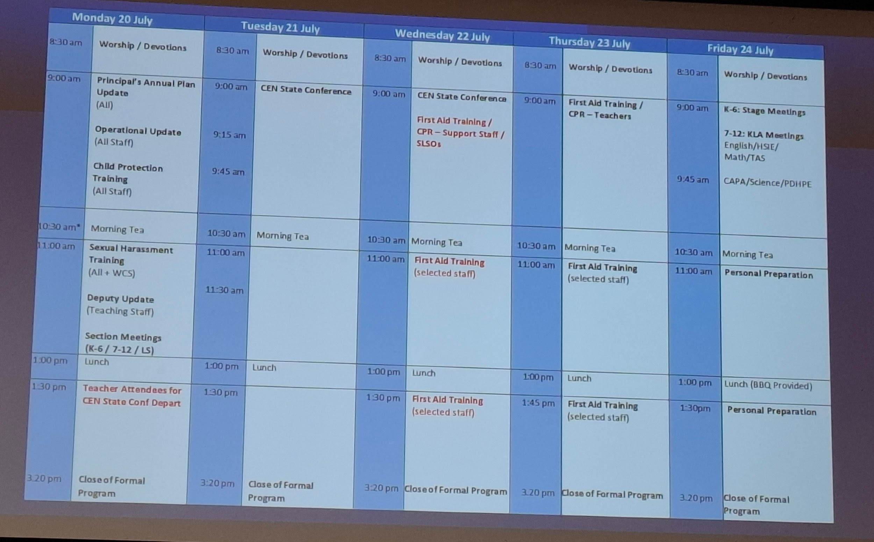

- Continuing staff roll out of devices
- 0.8 and 0.6, rolling over devices
  - Doing a third of devices at a time
- Classroom AV

- Phase 1
  - Primary Project - Complete
- Phase 2
  - Secondary Panels - Complete
  - Bell System - Ongoing
- Phase 3 - 2027
  - Remainder of AV for Secondary
  - Bell System completion

- QSIS System
  - $350,000
- V-Casting / Tetherless

- Paul Semple working on Bell System
- Lockdown and Fire Drill Procedure
- Different Bell times in Primary Secondary
  - Play music from 2027
- Student Devices
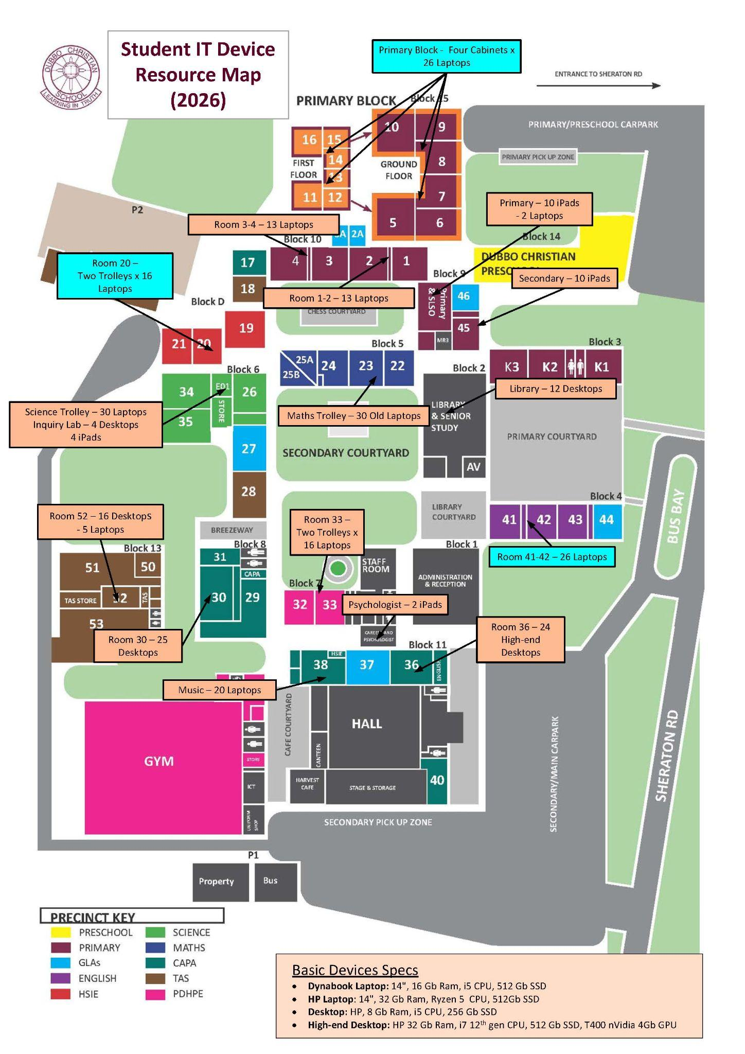
- Distribution as per learning outcomes across the school
- Room 37 is no longer PC Lab
- Now a GLA (General Learning Area?)
- Special Acquisition
- DCS Coach
  - Liz, Brooke
- General Points
  - BCE Strategic Planning
  - DCS Functional Analysis
- Policy and Procedures
  - PolicyConnect Registration Module
  - DCS Procedure Manual
- Support Staff Tasks
- Sentral Resource Bookings
  - Car
  - Withdrawal Rooms
- ⅓ to 40 percent, new since 2022
- RAV4 - 1 staff car for Term 1

- Finance
  - Virtual Credit Cards
  - Electronic PORs
  - All furniture purchases through Ingrid / Pedr
- Operations
  - All excursion and PD bookings through Lis
- MAGS/OAGS/DCS Seniors Cup
  - Strategy of retaining Seniors Students
  - Giving something to work for

